1. Here's your EduPulse Sign Up UI — clean, modern, and fully interactive! Here's what's included:
Features built in:
- Logo & branding — custom EduPulse mark with a campus/education icon
- All required fields — Full Name, Email, Phone Number, Password, Confirm Password
- Designation selector — pill-style toggle buttons (Student, Faculty, Security, Administrator) instead of a plain dropdown, which feels more intuitive and modern
- Live password strength meter — color-coded bar that updates as you type (Weak → Fair → Good → Strong)
- Responsive layout — stacks to a single column on smaller screens
- Sign in link at the bottom for returning users
Let me know if you'd like any changes — color scheme, layout, adding more fields, or building the next UI phse (like a Sign In screen or Dashboard)!

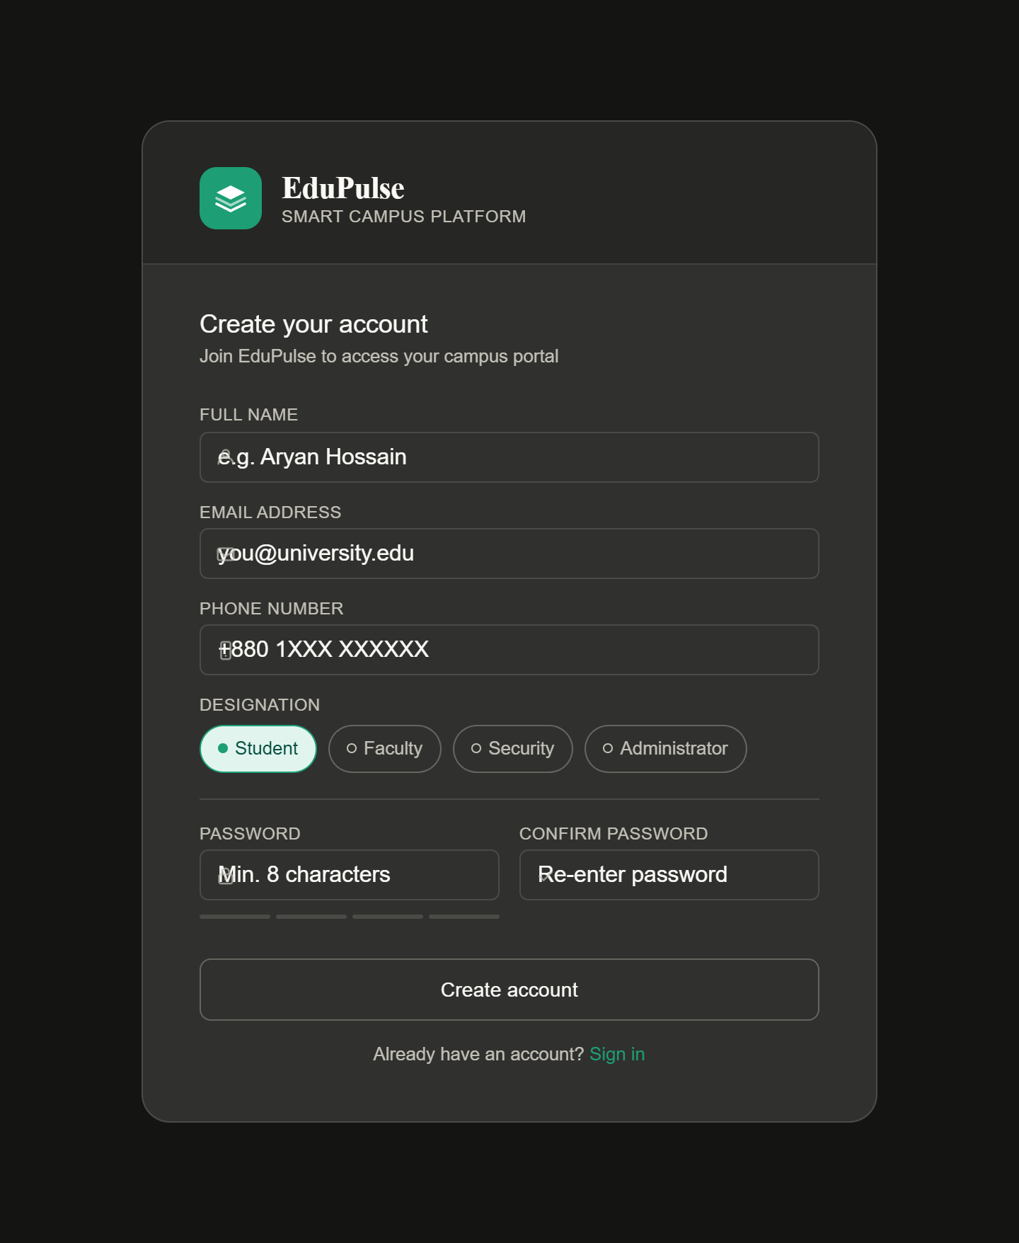

2. Here's the EduPulse Login UI, fully consistent with the Sign Up design! Here's what's packed in:
Features included:
- Designation tab switcher — Student / Faculty / Security / Admin tabs so users select their role before logging in
- Show/hide password toggle — eye icon on the password field
- Remember me checkbox — custom styled, toggleable
- Forgot password link — placed neatly opposite the checkbox
- Error state — red alert banner appears if fields are left empty on submit
- Campus SSO button — single sign-on option for university accounts
- Sign up link — navigates back to the registration screen
The color scheme, typography, and component style all match your Sign Up UI exactly. Let me know if you'd like the next phase — Dashboard, Forgot Password screen, or anything else! 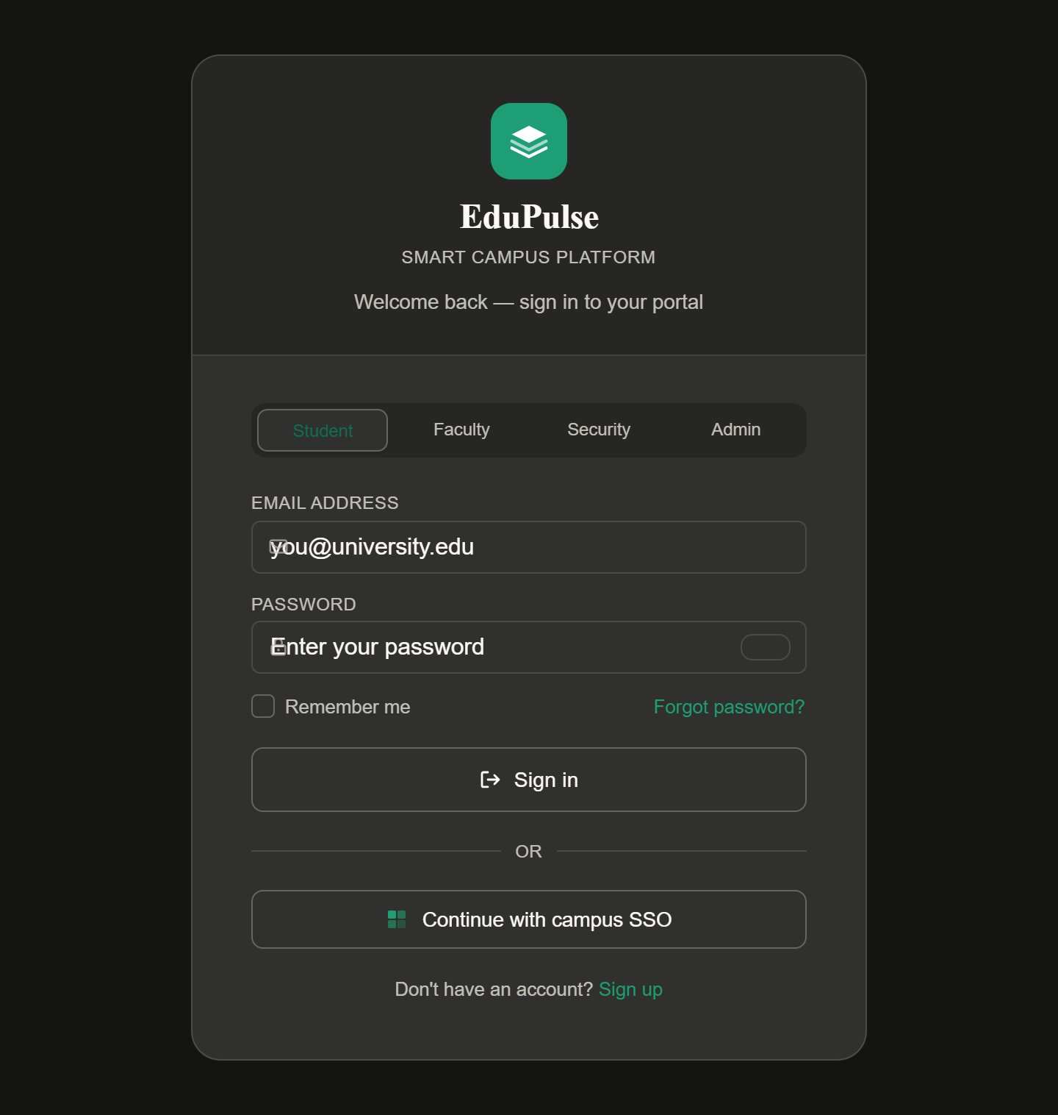

3. Here are all three role-based login screens — switch between them using the tabs at the top! Each portal has its own identity:
Faculty Portal (Blue)
- Faculty email + Staff ID + Password
- Campus SSO option
- "Request faculty access" link for new users
Security Portal (Amber)
- Badge ID + Shift Zone + 6-digit PIN (instead of a regular password)
- Shift zone field unique to security workflows
- "Contact your supervisor" instead of a sign-up link
Admin Console (Purple)
- Admin email + Admin ID + Password + 2FA one-time code field (extra security layer)
- "Trust this device" instead of "Remember me"
- "Reset credentials" and "Contact IT department" links — no public sign-up
All three share the same EduPulse branding, consistent component style, and interactive features (show/hide password, remember me checkbox, error state). Let me know what screen to build next — Dashboard, Forgot Password, or something else!
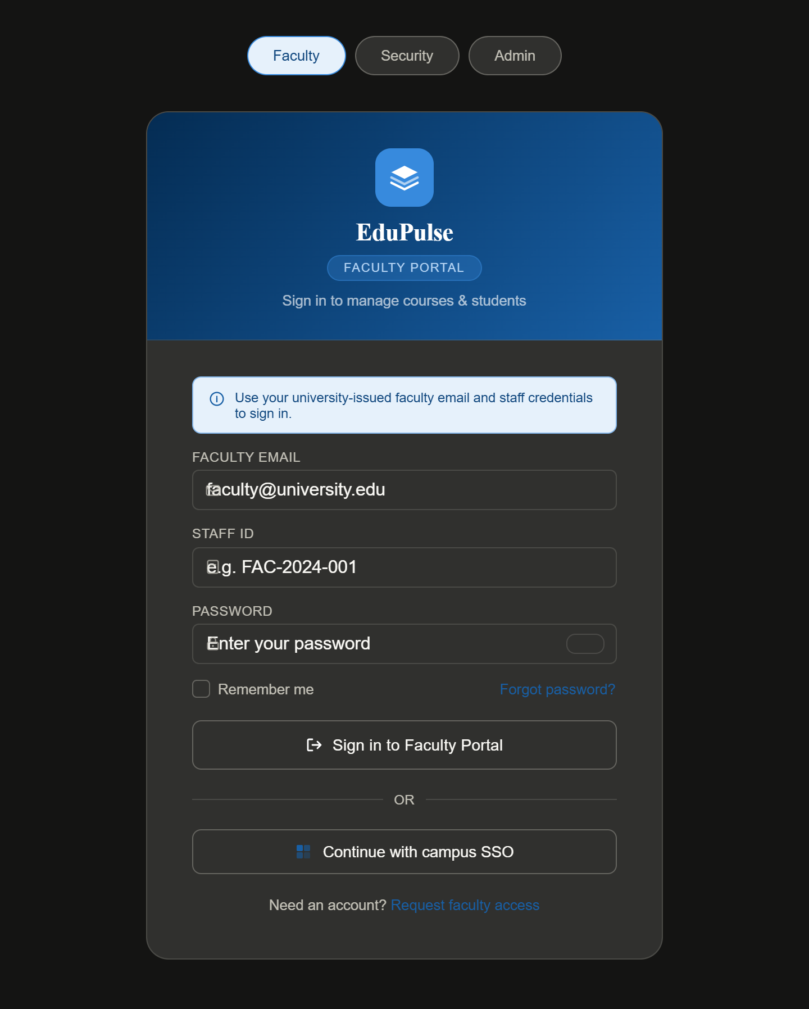

4. I'll clarify — do you mean the Security Dashboard (what a security person sees after logging in), or something else like a security management screen?
Let me build the Security Personnel Dashboard — the main screen they'd use after signing in.Here's the full Security Personnel Dashboard for EduPulse! Here's what's inside:
Top bar — EduPulse branding in amber/dark theme, officer name, assigned zone, shift time, and notification bell with an active alert dot.
Sidebar navigation — Overview, Incidents, Patrol Log, Gate Control, Visitor Log, Zone Map, Reports, Shift Schedule.
Live alert banner — highlighted warning for the active unauthorized access incident.
4 metric cards — Active incidents, Gates open, Officers on duty, Visitors today.
Incident log — table with ID, description, zone, severity (High/Medium/Low pills) and status (Open / In Progress / Resolved).
Gate control — 6 campus gates with live open/close toggle buttons (fully interactive — click them!).
Patrol zones — all 6 zones with assigned officer names and status (Secure / Alert / On patrol).
Recent activity feed — color-coded timeline of the latest campus events.
Let me know if you'd like the Faculty Dashboard, Admin Dashboard, or any other screen next!
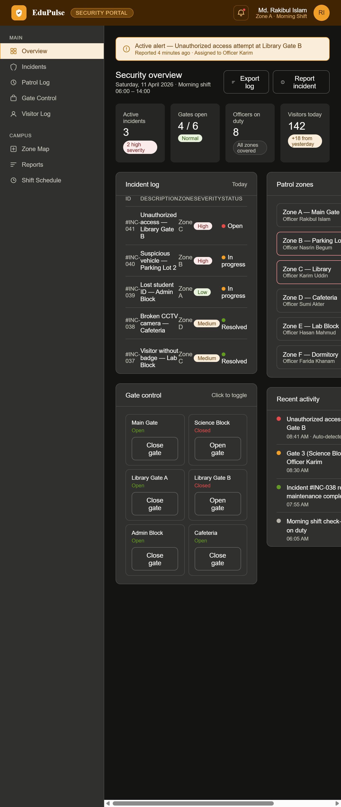
5. Here's the dedicated Security Login UI for EduPulse — a polished two-step login flow! Here's what's inside:
Left panel (amber/dark branding)
- EduPulse shield logo with Security Portal identity
- Motivational heading and description
- Live zone status feed (Zone A Secure, Zone B Alert, Zone C On patrol) — gives officers a quick campus overview before even signing in
Step 1 — Credentials
- Security Badge ID field
- Registered Email field
- Shift Zone field
- Campus SSO option
- Validation — shows error if fields are empty
Step 2 — PIN Verify (after Step 1 passes)
- 6 individual PIN box inputs — auto-advances focus box to box as you type, backspace goes back
- "Keep me signed in" toggle checkbox
- "Forgot PIN?" link
- Error state for incomplete PIN
- Step indicator updates — Step 1 gets a green checkmark, Step 2 activates
The two-step flow adds a layer of security realism perfect for a campus security system. Let me know what to build next — Faculty Login, Admin Login, or any dashboard screen!
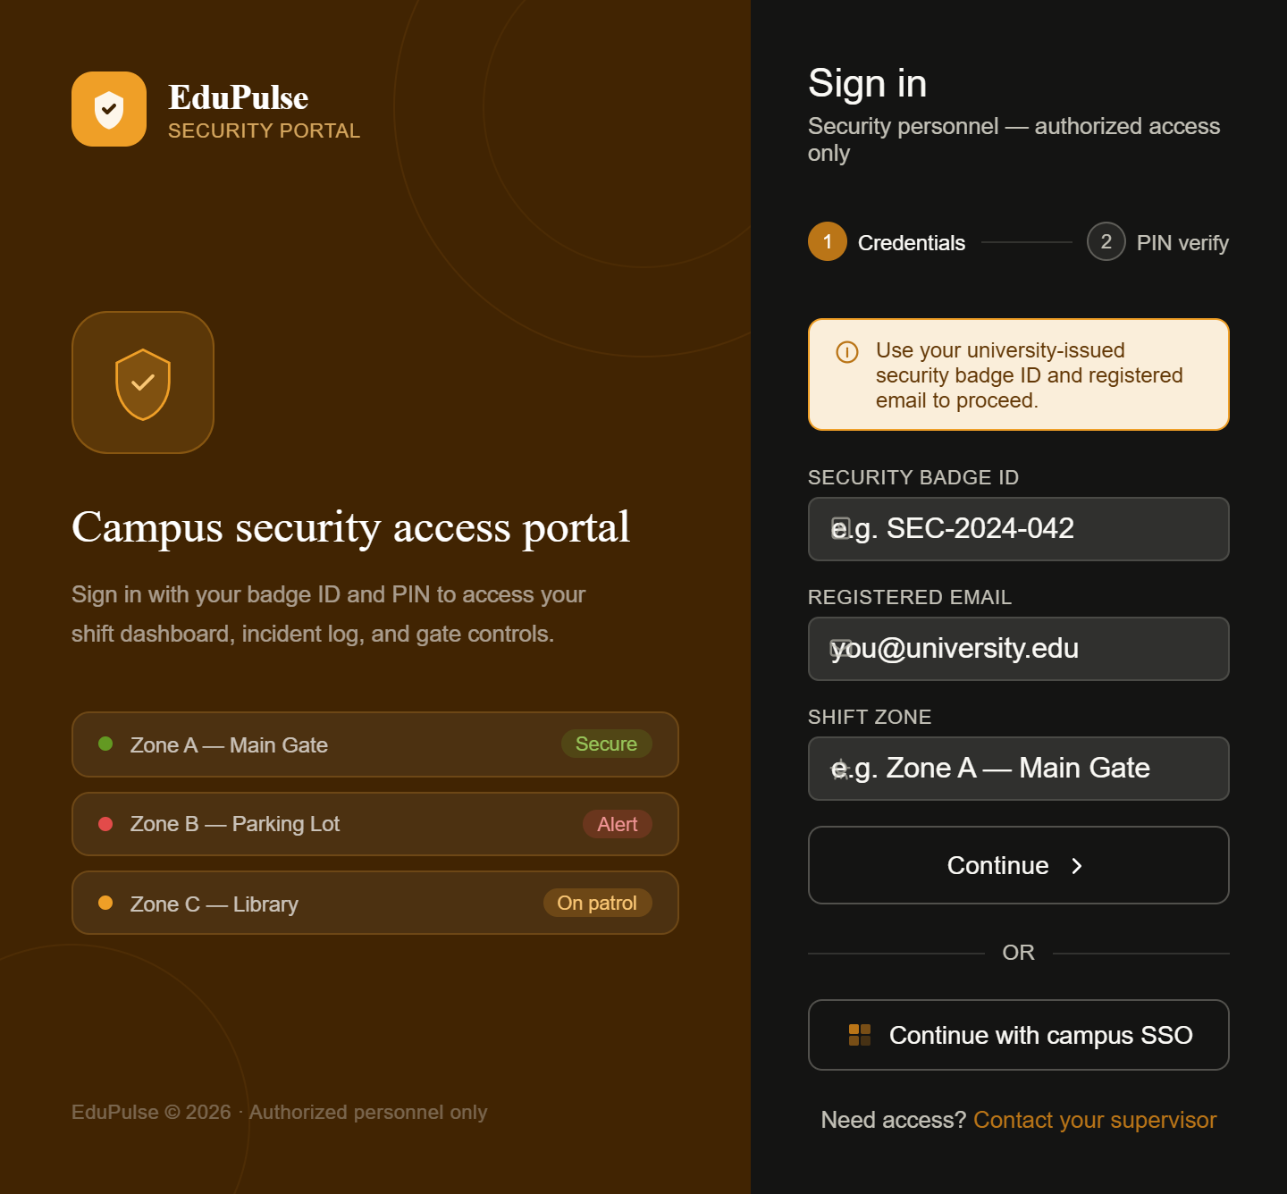

6. Here's the full EduPulse Admin Login UI — a secure 3-step verification flow! Here's what's packed in:
Left panel (purple/dark branding)
- EduPulse logo with Admin Console identity
- Description with a security warning note
- Access level cards showing System Administrator (Full), Department Head (Limited), and Auditor (View only) roles
Step 1 — Identity
- Admin Email, Admin ID, and Role fields
- Campus SSO option
- Validation error if fields are empty
Step 2 — Password
- Password field with show/hide toggle
- Re-enter Admin ID for identity confirmation
- "Trust this device for 30 days" checkbox
- "Reset password" link
- Lockout warning in error state (3 attempts remaining)
Step 3 — 2FA Authenticator
- 6-box OTP input (auto-advances focus, backspace goes back)
- Live 30-second countdown timer — shows "Code expired" when time runs out
- "Use backup code" option
- "Lost authenticator? Contact IT support" link
The step indicator at the top tracks progress — each completed step gets a green checkmark. Let me know what to build next — Faculty Login, Student Dashboard, or any other screen!
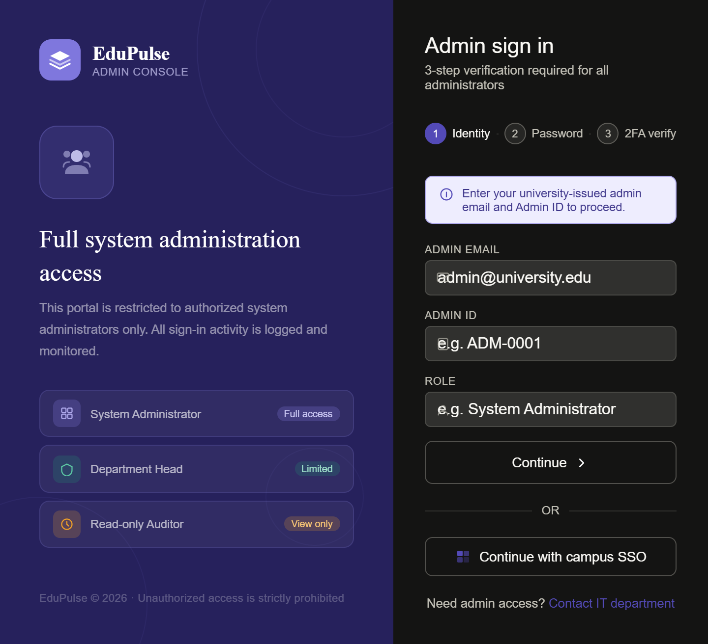

7. Here's the complete EduPulse Facial Recognition Setup UI — fully interactive! Here's everything inside:
Top bar — EduPulse branding with "Biometric Setup" badge and live step indicator.
Left sidebar:
- 4-step setup progress tracker (Step 1 done ✓, Step 2 active, Steps 3–4 idle)
- User profile card with enrollment status badge
- Capture tips panel with best practices
Camera viewport (main area):
- Dark scanning environment with face oval guide and animated scan line
- Pulsing corner brackets that react to state
- Live progress pill showing current action
- Overlay text with per-angle instructions
Capture strip + button — shows Front / Left / Right thumbnail placeholders that fill with a green checkmark as each angle is captured. Hit "Capture" 3 times to walk through the full flow!
Angle guide cards — 3 cards (Front, Left turn, Right turn) that update state (Pending → Active → Captured) as you capture each angle.
System requirements panel — live checklist showing camera status, lighting, face detection, glasses warning, centering, and secure connection.
Interactive flow:
- Click "Capture" → simulates processing → angle marked done → moves to next angle
- After all 3 are captured → success state → green confirmation banner appears → "Continue" to next step
- "Reset" button clears everything and starts over
Let me know what to build next — the AI Model Training step, the Confirmation screen, or any other UI phase!

